1. Create a diagram explaining client-server communication flow and explain howa request isprocessed by the server and

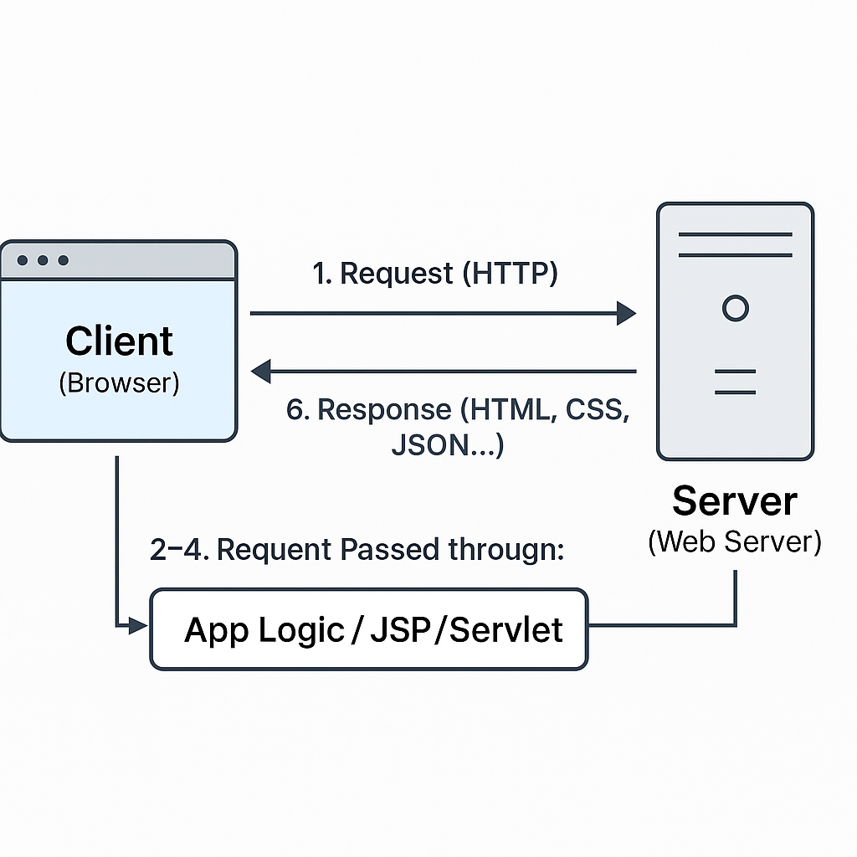

1. Draw and explain the J2EE architecture, labeling the layers like the presentation layer, business logic layer, and data layer.

